Azure Assignment

(AZ – 104- Module 1)

Avishekh Sinha

# Module 1 - Basics

## Assignment 1

1. Connect to azure cloud shell.

Ans: Step1: Opened the azure portal and clicked on the cloudshell button.

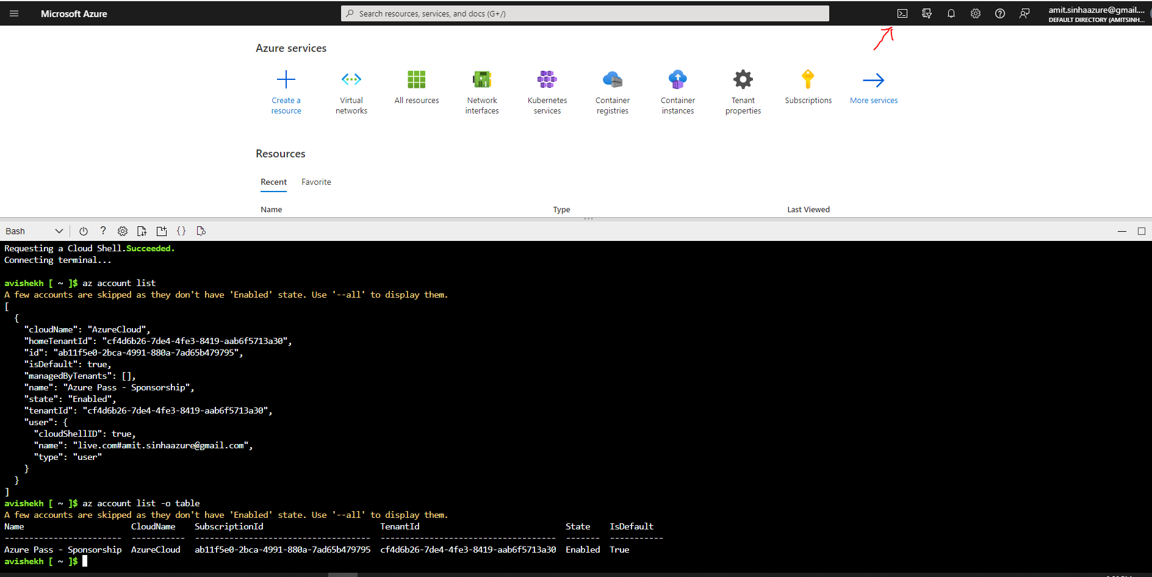

1. Create a resource group “new-rg” in South Central US region

Command: **az group create -l southcentralus -n new-rg**

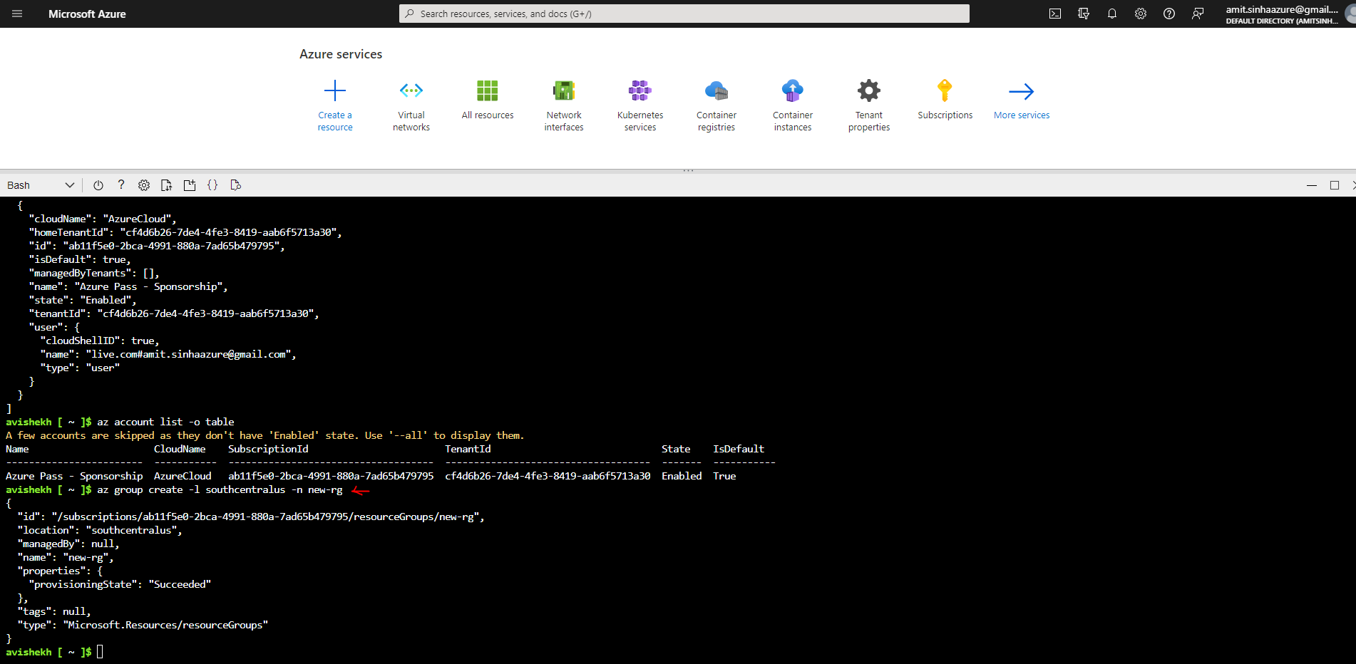

List the Resource Group

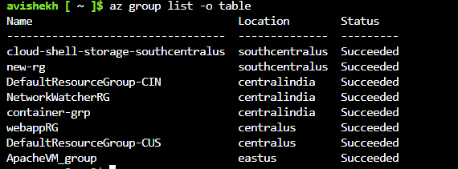

## Assignment 2

1. Connect Azure powershell to your azure account

2. Create a new resource group in South Central US with the name “rg-powershell”

Ans -

Command - **New-AzResourceGroup -Name rg-powershell -Location "South Central US"**

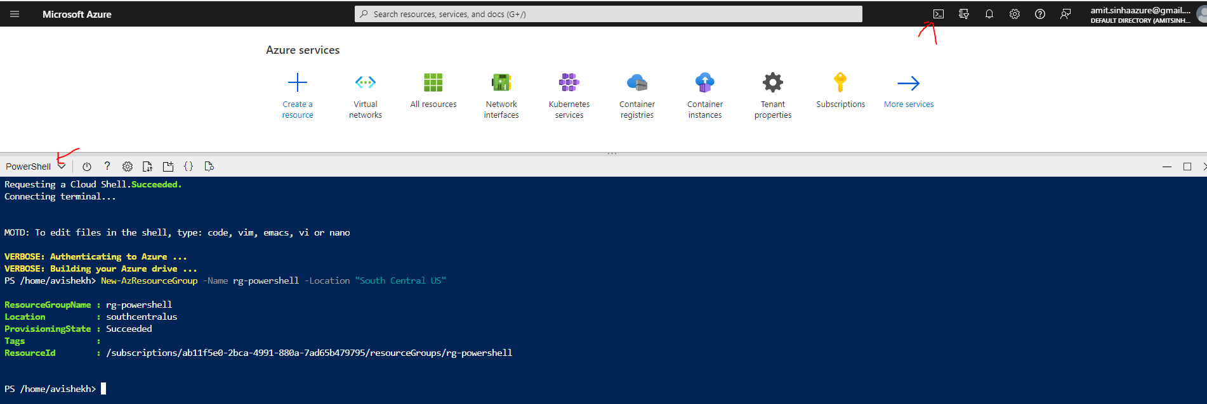

## Assignment 3

**USING POWERSHELL**

Create three more Resource groups in a specific region let’s say “West US”

Ans -

Command - **New-AzResourceGroup -n p-new-rg1 -l westus && New-AzResourceGroup -n p-new-rg2 -l westus && New-AzResourceGroup -n p-new-rg3 -l westus**

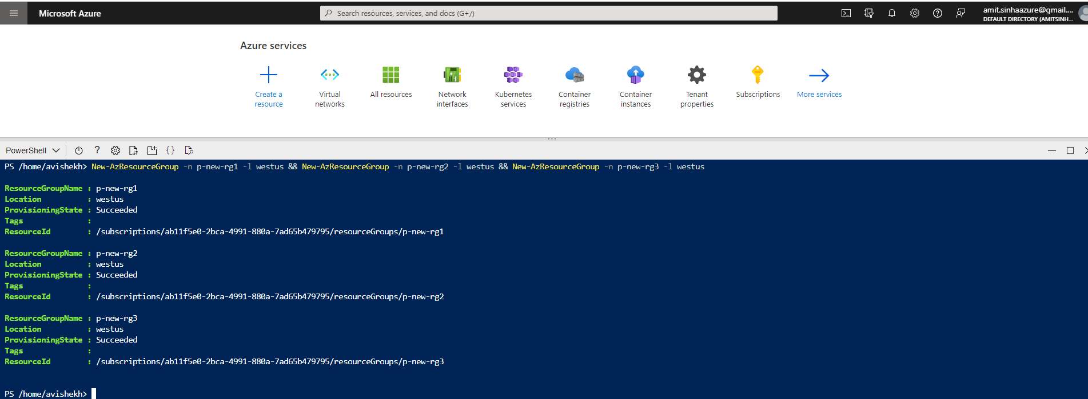

2. List all resource groups in West US

Command- **Get-AzResourceGroup -Location westus | FT**

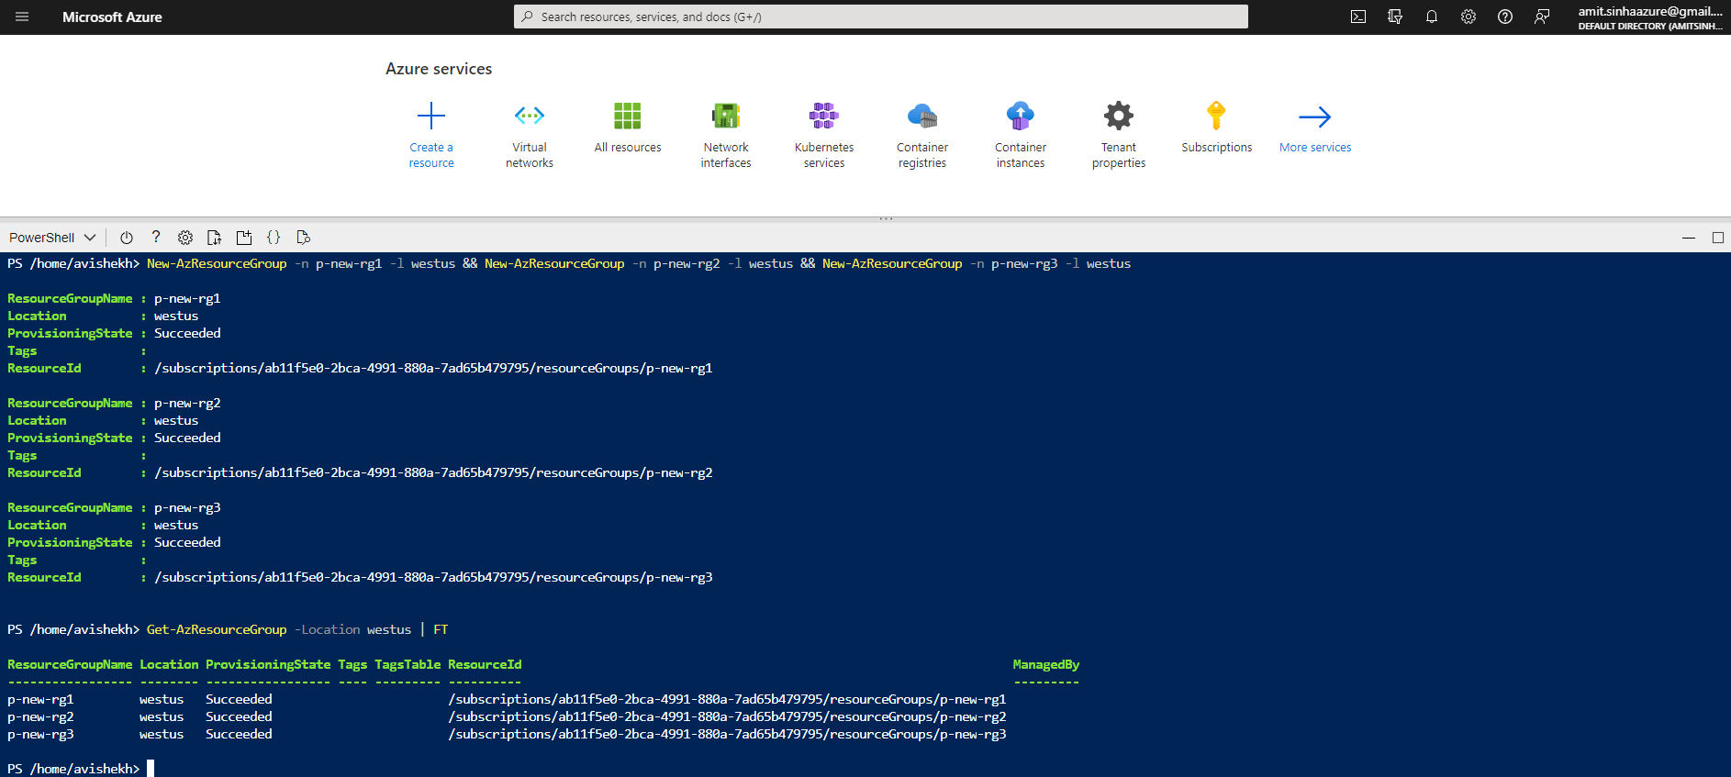

**USING AZURE CLI**

Create three more Resource groups in a specific region let’s say “West US”

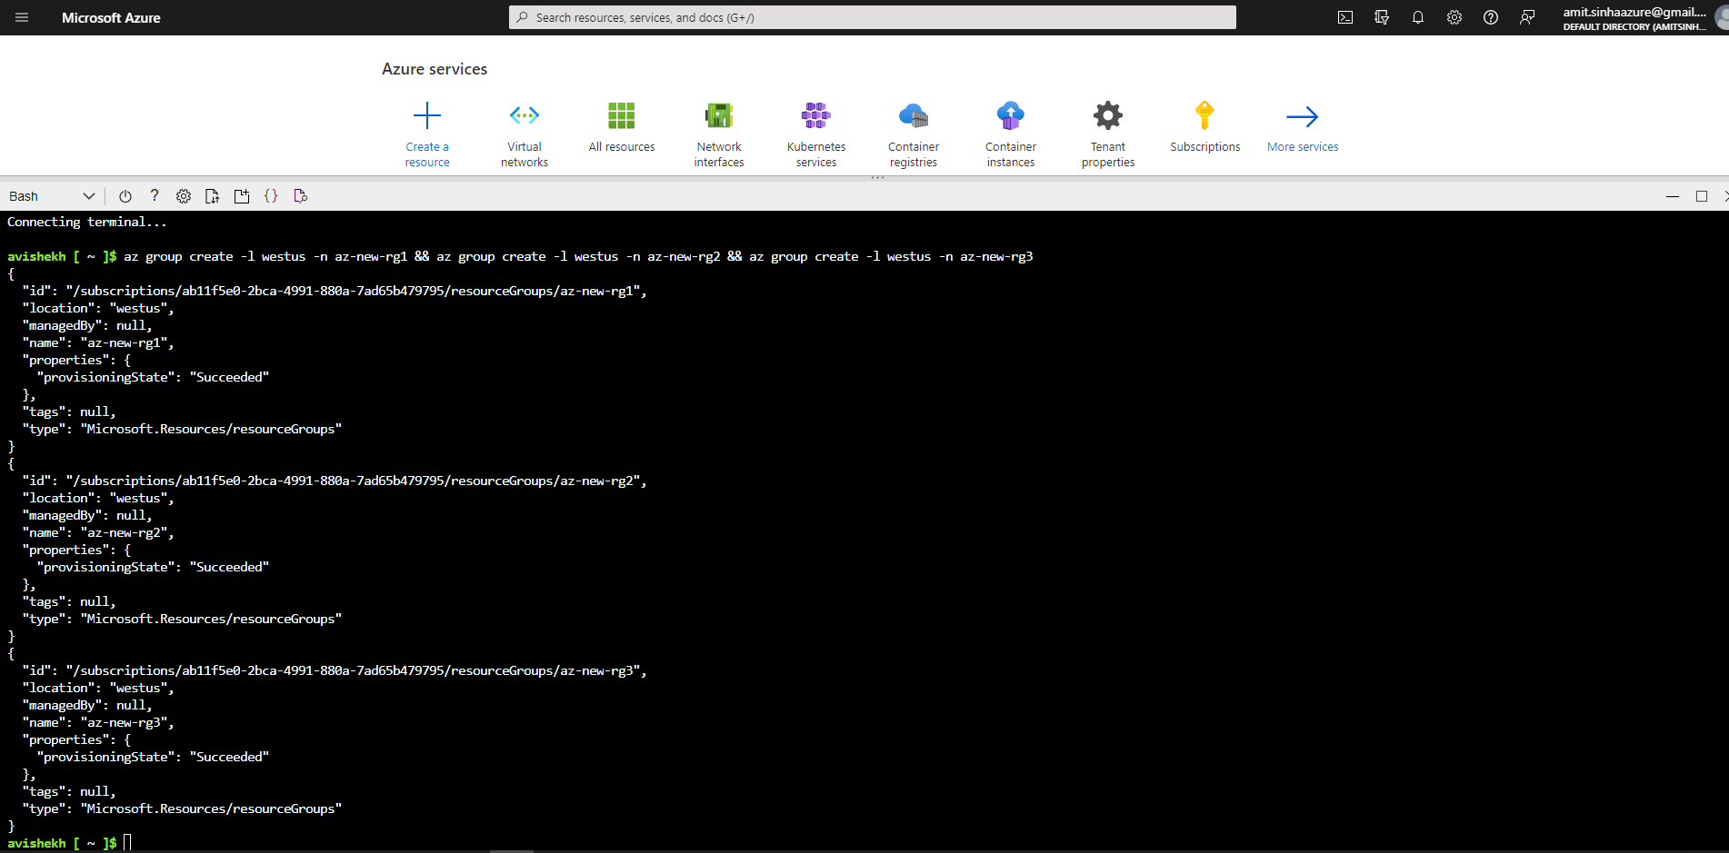

2. List all resource groups in West US

**Command - az group list --query "[?location=='westus']" -o table**

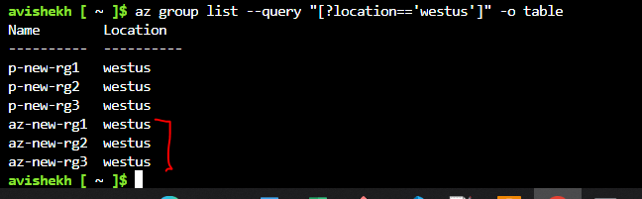

## Assignment 4

Delete all the resource groups in West US region using one command

Ans

**USING AZURE CLI**

Command - **az group list --query "[?location=='westus']".name -o tsv | xargs -otl az group delete -n**

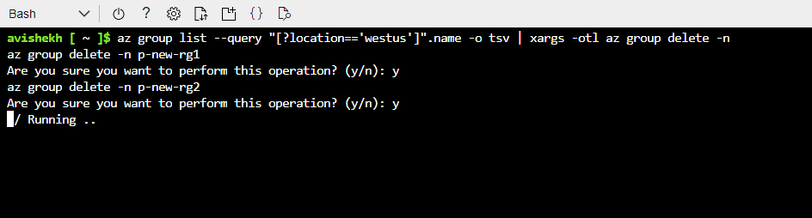

**USING POWERSHELL**

**Command - Get-AzResourceGroup -l 'westus'| Remove-AzResourceGroup**

